**CSIS 2260 - Lab #2**

20

***Windows 10 System Performance and Disk Management***

Due date: 20:59 Jan 22, 2021 (Pacific Time)

**Name: Stephen Joy Student No.: 300329148 Section: 012**

**Insert the required screenshot(s) in the Word file. Do not submit the screenshot(s) separately.**

**Use a different font color for your answers.**

**Objectives:** To learn about Windows 10 performance related functions and disk management.

**Open Oracle VM VirtualBox Manager and start the Windows 10 virtual machine created in Lab 1. Work on the following parts on the virtual machine.**

1. **System Performance [____/12]**
2. From ***Start*** *>* ***Windows System*,** right click on ***This******PC*** and select ***Properties***.

* Scroll down the right panel and click the ***Advanced system settings*** under *Related settings*.
* From the pop-up window, in the ***Performance*** section, click the ***Settings*** button.
* In the Performance Options Dialog box, click the ***Advanced*** tab.
* Check the *Virtual memory* section, and briefly describe the term ***Paging*** ***File***.

**- A paging file is an area on the hard disk that Windows uses as if it were RAM.**

* In the *Virtual memory* section, click the ***Change*** button. The Virtual Memory dialog box opens. List the current settings in the following:
  1. Drive(s) where a paging file is located: **“Automatically manage paging file size for all drives”** option is checked by default.
  2. Recommended size: **1151 MB**
  3. Currently allocated size: **1152 MB**

Click ***Cancel*** a few times to close all the pop-up windows.

1. From ***Start*** *>* ***Windows Administrative Tools****,* open ***Resource******Monitor***.

* What are the FOUR main resources that the system monitors their performance and usage?

**- CPU, Disk, Network and Memory**

* Click the ***Memory*** tab. The usage of the physical memory on your system is **57**%
* Amount of physical memory in use is **1178**MB.
* Amount of physical memory available is **833**MB.
* What is a *Hard* *Fault*? (You can use Google search.)

**- Despite their name, hard faults are not errors. A hard fault occurs when Windows has to access the swap file--reserved hard disk space used when RAM runs out.**

Close ***Resource******Monitor***.

1. From ***Start*** *>* ***Windows******Administrative******Tools****,* open ***Performance******Monitor***.

* Under ***Data******Collector******Sets*** > ***System***, select ***System******Performance*** on the left window, and click the green arrow at the top to start running it.
* From ***Reports*** *>* ***System*** *>* ***System******Performance***, select the newly created report (You may need to wait until the system finishes collecting data before you can open the report).
* From ***Diagnostic* *Results*** > ***Performance* >** ***Resource* *Overview***:
  1. The CPU utilization is **4**%.
* From ***CPU*** > ***Process***:

1. From *Image Statistics*, how many processes are there in total (note: only the top 3 out of the total processes are shown by default)? **3**
2. From *Process*, what is the ***Mean*** value of ***Thread Count*** in the system? **886**

Note that a ***process*** can create multiple ***threads*** and the number of threads in the system is much higher than the number of processes.

Keep the ***Performance******Monitor*** window open.

1. From ***Start*** > ***Windows*** ***System***, right-click ***Command Prompt*** and select ***Run as administrator***. Enter ***winsat formal*** to run the System Assessment tool. Wait until the System Assessment tool finish running before proceeding.

* Again, from ***Performance******Monitor***, under ***Data******Collector******Sets*** > ***System***, select ***System******Diagnostics*** on the left window, and click the green arrow at the top to start running it.
* From ***Reports*** *>* ***System*** *>* ***System******Diagnostics****,* select the newly created report.
  1. From ***Diagnostic* *Results*** > ***Basic* *System* *Checks***, list the FIVE main items that have been checked. Indicate if any items failed the test.

**- OS Checks**

**- Disk Checks**

**- Security Center Tests**

**- System Service Checks**

**- Hardware Device and Driver Checks (Failed)**

* 1. From ***Software* *Configuration*** > ***System* *Services***, click + to expand the ***System******Services***
     + Expand the service “DHCP”. Is this service running? **Running**

Briefly describe this service (you may click + for more information).

* + - **Registers and updates IP addresses and DNS records for this computer. If this service is stopped, this computer will not receive dynamic IP addresses and DNS updates. If this service is disabled, any services that explicitly depend on it will fail to start.**
    - Expand the service “LSM”. Is this service running? **Running**

Briefly describe this service.

* + - **Core Windows Service that manages local user sessions. Stopping or disabling this service will result in system instability.**

* + - Expand the service “SPOOLER”. Is this service running? _____________

Briefly describe this service.

* + - **This service spools print jobs and handles interaction with the printer. If you turn off this service, you won't be able to print or see your printers.**

* 1. From ***Hardware*** ***Configuration*** > ***Desktop*** ***Rating***, expand the Desktop Rating and give the values of

CPU Score - **7.9**

Disk Score - **8.65**

Memory Score - **5.5**

Note: the scores should be non-zero numbers. If you get zero for the ratings, you should repeat the instructions in step 4 again and make sure you run the Command Prompt as administrator.

Close the ***Performance******Monitor*** window.

1. From ***Start*** *>* ***Windows******System****,* open ***Task******Manager*** and click ***More******details***.

* How many *Apps* are running? ­­­­­­­­­­­**1**
* How many *Background* *processes* are running? **28**
* Select the ***Startup*** tab. How many processes will start automatically during system start up? **2**

Close the ***Task******Manager*** window.

1. **Disk Management [____/6]**

* From ***Start*** *>* ***Windows******System****, r*ight click on ***This******PC*** and select ***Manage***.
* In the left pane, click ***Disk******Management***, and review the information in the center pane.
* List the information on the following:

1. Number of hard disk(s) installed: 1
2. Capacity of the whole hard disk: **50.00 GB**
3. Letter assigned to the Primary Partition: **C**
4. The type of file system used for the Primary Partition: **NTFS**

* Create a new partition:
  1. Right-click on C: and select ***Shrink******Volume****.*
  2. Shrink the C: drive to about ***30 GB*** (you need to adjust the amount of space to shrink in MB such that the total size after shrink should be about 30 GB, which is around 30,000 MB).
  3. Right-click the unallocated space and select ***New Simple Volume*** to create a new volume with NTFS as the file systems (click *Next* a few times and *Finish*).
* Drive letter: **E** Size: **19.46 GB**
* Take a screenshot of the ***Computer******Management*** window and insert the screenshot here.

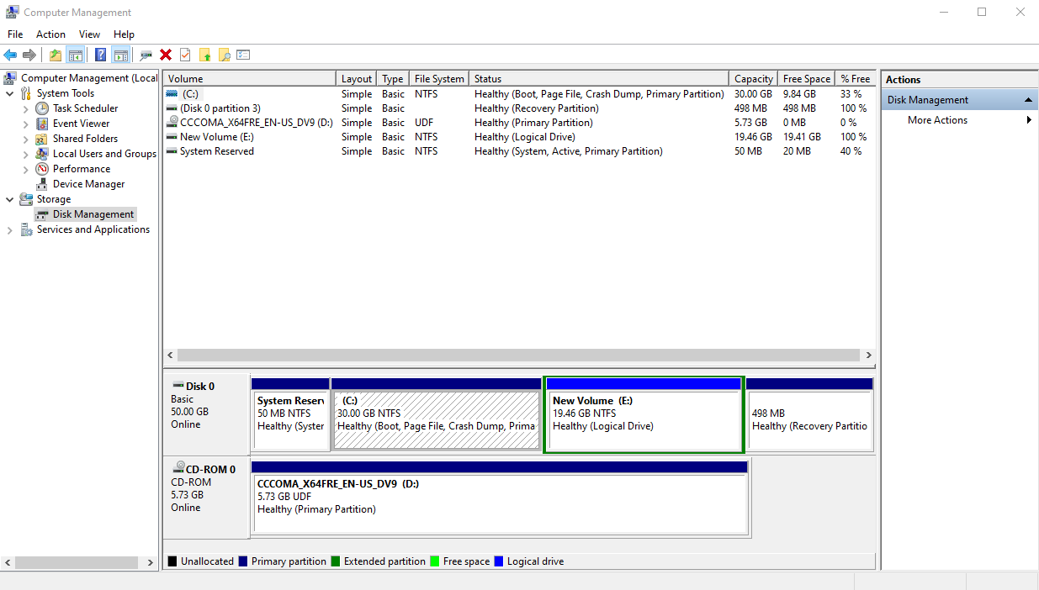

* Close the ***Computer******Management*** window.

1. **Hard Drive Routine Maintenance** **[____/2]**

* From ***Start*** *>* ***Windows******Administrative*** *Tools,* open ***Disk******Cleanup***
* Select C: drive and click *OK*.
  1. Briefly describe the function of Disk Cleanup.

**- Disk Clean-up is a computer maintenance utility included in Microsoft Windows designed to free up disk space on a computer's hard drive. The utility first searches and analyzes the hard drive for files that are no longer of any use, and then removes the unnecessary files.**

* 1. List the types of files that the system may suggest for removal (the file options checked by default).

**- Downloaded Program Files**

**- Temporary Internet Files.**

**- Thumbnails**

1. **Shutdown the Virtual Machine**
2. Shut down the system.
3. Close Oracle VM VirtualBox Manager.

**Submission**

1. Save your lab file as YourFirstname_yourID_Lab2.docx (example: Michael_1234_Lab2.docx)
2. Submit the WORD file through Blackboard before the due (do not send labs by email please. Any lab submitted by email will be ignored).
3. You may submit your work multiple times, but only the LAST submission before the due will be marked.